**Creating charts in spreadsheets**

In this reading, you are going to learn more about how to create charts directly in your spreadsheet using existing data. Let’s discuss that process now with a Google Sheet. You can use [this spreadsheet](https://docs.google.com/spreadsheets/u/1/d/1vZwQiubOmvJ0RG_cwHFi5rke3kU-Woxx9dBeF0SO2Dg/copy) (make a copy or download from the file below), which you may recognize from a previous video, or you can apply it to your own spreadsheet. Remember that these steps might be slightly different in Excel, but you should be able to apply them to any spreadsheet program.

[Cosmetics Inc..xlsx](https://d3c33hcgiwev3.cloudfront.net/1ZnlU4sFQWiZ5VOLBQFoKw_a3f577eb11f14ffca3f4f9bc9d0067c7_Cosmetics-Inc..xlsx?Expires=1618012800&Signature=LtEE8bSwu0UT3pMee8oGD4ciVRNk5iVCMJvafcUHsM2jGT5S~zlqb6DU~9YXk54~OZd7FUHPsqvL2elEx0uCDZPVnYQ1AvlvykYVm91TYhtA2PK7ZmSMCQw5WN6ZXkU8-YSuo3HJE~PprxA0F9R7y6BvfOFS-R10MIDElYBt~lc_&Key-Pair-Id=APKAJLTNE6QMUY6HBC5A)

**Step 1:**

Open the spreadsheet. If you are using the spreadsheet we provided, practice creating a chart in tab 2, labelled "Create your chart here." To do this, select the data you wish to create a chart from, click the menu option labeled **Insert**, and select **Chart**.

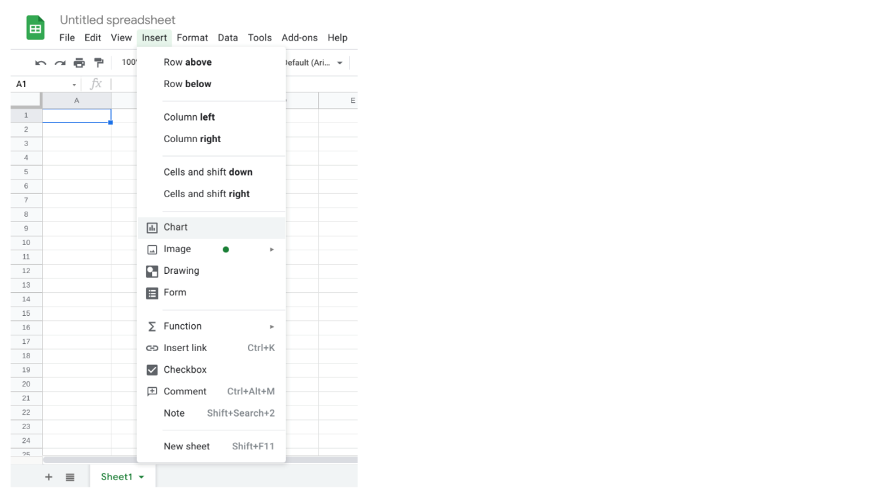

**Step 2:**

Explore the **Chart editor** that will open on the left.

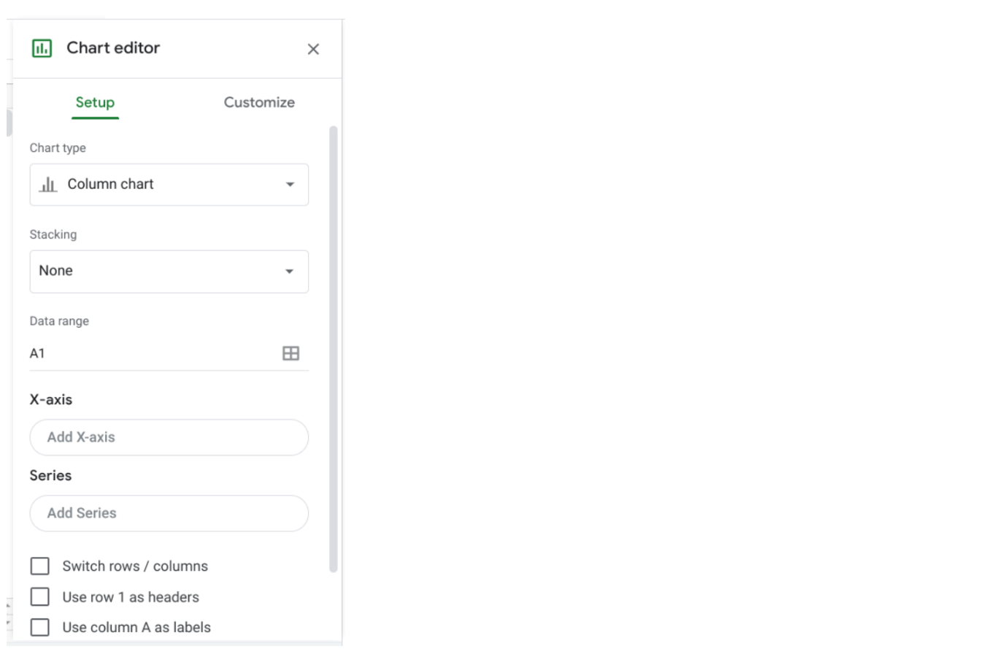

From the editor, you will be able to select which kind of chart you want to create.

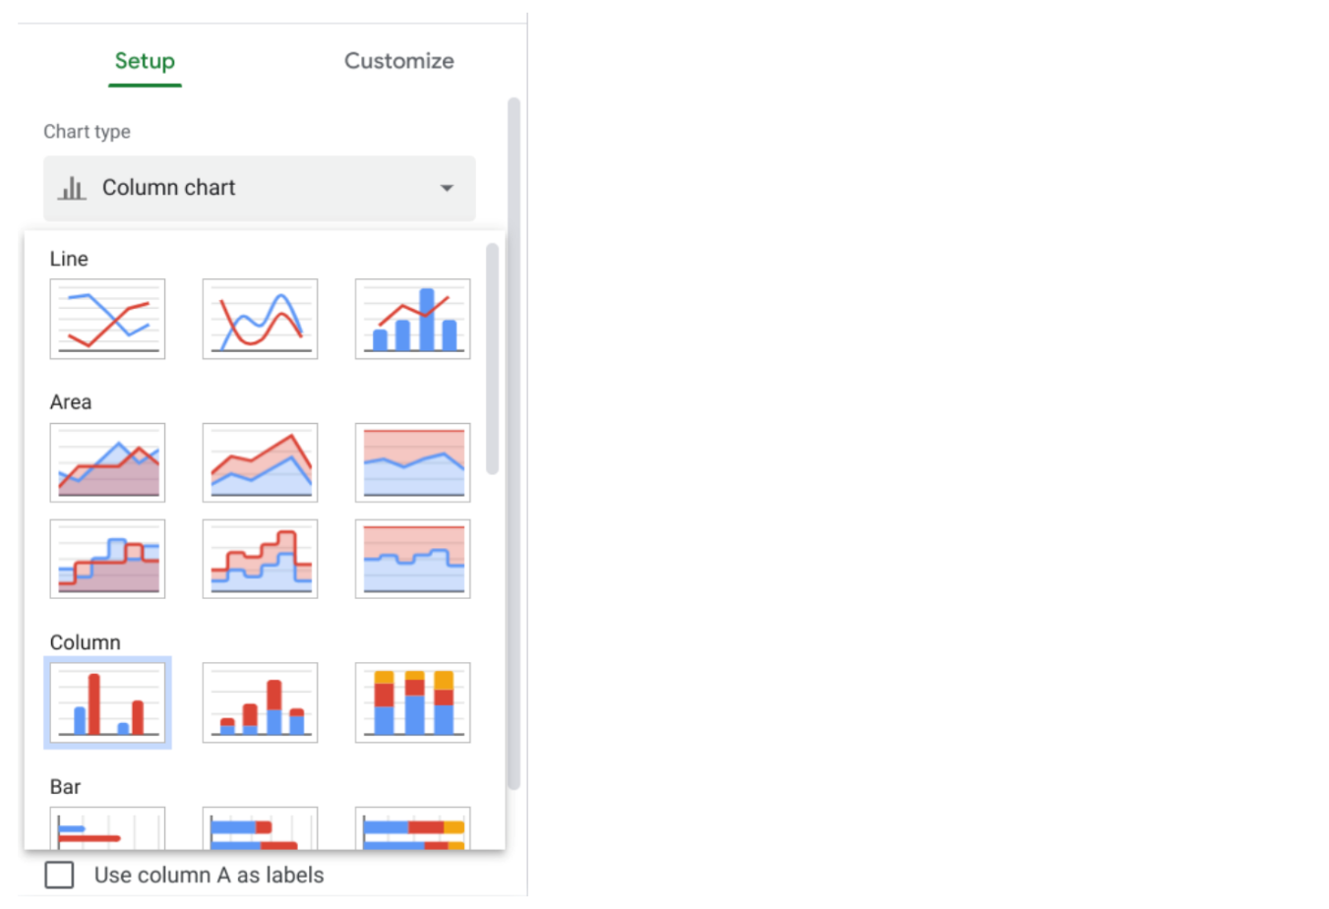

After you have selected the chart type that is most appropriate for your data and your goals, you can check that the data is on the appropriate axis of the chart and customize it. Creating charts in your spreadsheet helps keep your visualizations connected to the data and gives you a quick way to visualize trends. For more detailed guides to creating visualizations in spreadsheets, check out these articles:

* [**Create a Microsoft Excel chart from start to finish**](https://support.microsoft.com/en-us/office/create-a-chart-from-start-to-finish-0baf399e-dd61-4e18-8a73-b3fd5d5680c2)**:** This how-to guide from Microsoft’s support site includes instructions and a video tutorial for adding charts to Excel spreadsheets. This is a useful resource if you are working specifically with Excel spreadsheets. It also links to other useful articles about creating charts in Excel.
* [**Add and edit a chart or graph in Google Sheets**](https://support.google.com/docs/answer/63824)**:** This article is similar to the previous resource; it includes steps for creating, editing, and changing charts in Google Sheets with how-to videos. It also has a more in-depth guide to editing and customizing your chart after you have created it.

**Additional resources**

Here are a few more resources you can reference as you learn more about charts in spreadsheets:

* [**Microsoft Excel: Creating and modifying charts**](https://guides.lib.umich.edu/c.php?g=283162&p=1886446)**:** This is an explanation of Excel charts with downloadable handouts. This resource is especially useful because it has downloadable content that you can save to reference later when you start creating charts in your own spreadsheets.
* [**Graphs in Google Sheets**](https://www.datacamp.com/community/tutorials/graphs-in-spreadsheets)**:** Not only does this resource contain a detailed example of chart creation in spreadsheets, but it also provides you with downloadable sample data you can use to practice. As you have learned throughout this course, practicing these skills helps you learn more about the tools you are using. This example data is a great way to start!